Introduction to GitHub
Welcome! This document serves as a general introduction to making an account on GitHub, joining the Poulin Lab organization and adding code.
Table of Contents
Creating a GitHub Account 1
GitHub Education 2
Joining the Poulin Lab Organization 4
Storing & Sharing Code 5
Creating Repositories 5
Adding Code 7
Sharing Code with Members Outside the Lab 8
Modifying Code and Development 11
Creating Branches Within Repositories 11
Committing Changes 14
Pull Requests & Merging Branches 17

While this document focuses primarily on uploading and sharing code, the second half does touch on the basics of development. For further reading on using GitHub as a workspace, resources are available below:
https://docs.github.com/fr/get-started/start-your-journey/hello-world
https://skills.github.com/
https://docs.github.com/en/get-started/start-your-journey/about-github-and-git

Creating a GitHub Account
To add code and join the lab organization, you should create a GitHub account. Ideally, each member of the lab should have their own GitHub account.
To create a GitHub personal account, navigate to the main GitHub page: https://github.com/. Enter your email (ideally McGill email) and create a password.
Once made, log into GitHub. The main page of the website should look like this:
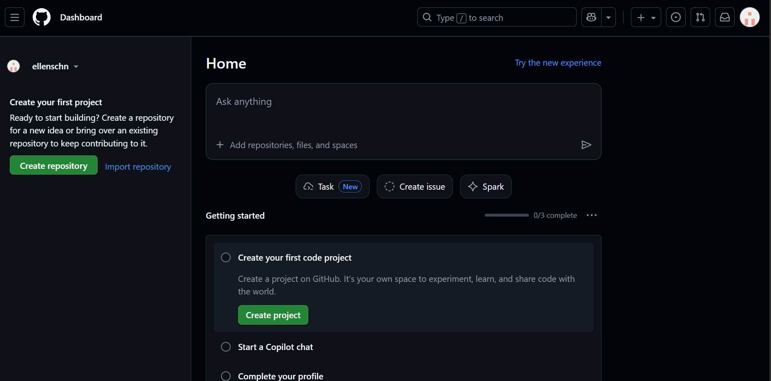

GitHub Education
Note: this part isn’t necessary, just a nice feature of GitHub.
As a McGill student, you can sign up for GitHub Education for free! You can read on the benefits here: https://github.com/education
To sign up for GitHub Education, navigate to your settings. Click Billing and licensing -> Education benefits.
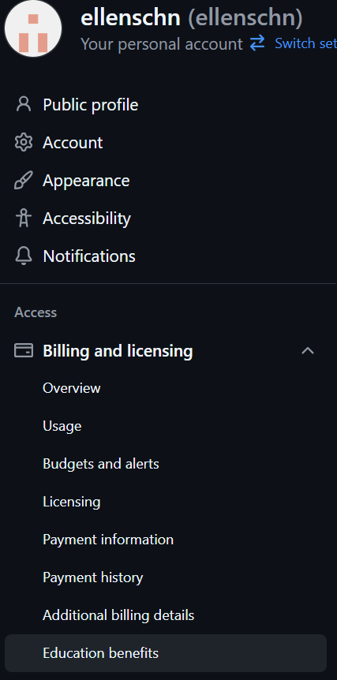
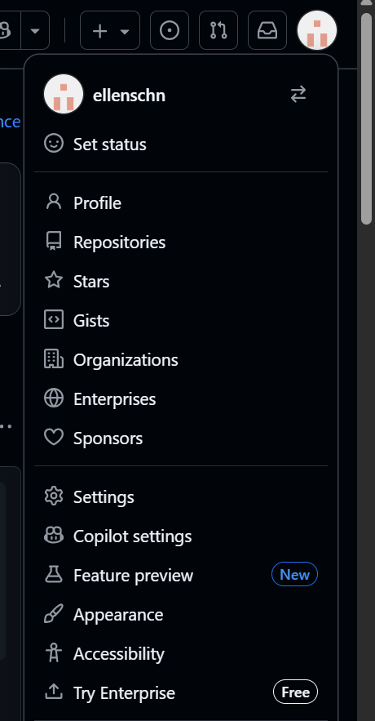
4
3
2
1
Start an application and follow the prompts. You will need to share your location and upload a proof of enrolment (can be in the form of Student ID, transcripts, enrolment letter, etc.)
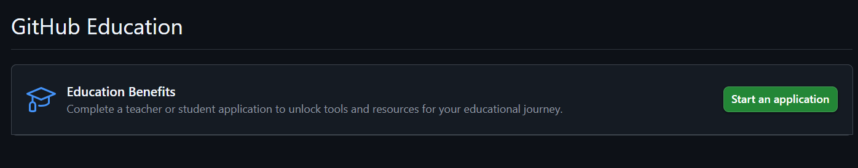

Once your application is approved, you can access all the Education benefits!

Joining the Poulin Lab Organization
An organization is a shared space between all lab members to add, modify and share their code. To join the Poulin Lab Organization, you must be invited by an organization admin. Admins include JF Poulin and Duncan Spencer. Ensure that you are receiving an invitation to the email you signed up to GitHub with.
To access the organization in GitHub, navigate to the Organizations section, and then click Poulin Lab.
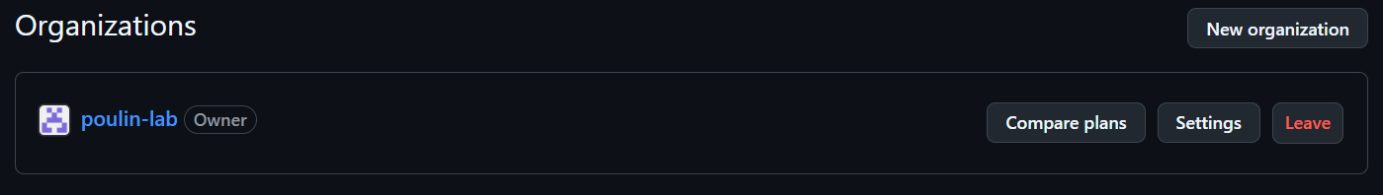
1
2

For Admins: How to Invite Members
Start on the main page of the Poulin Lab organization and navigate to the “People” tab.
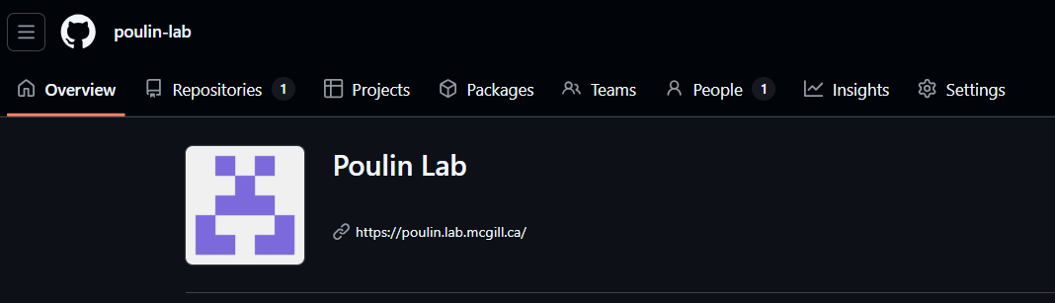

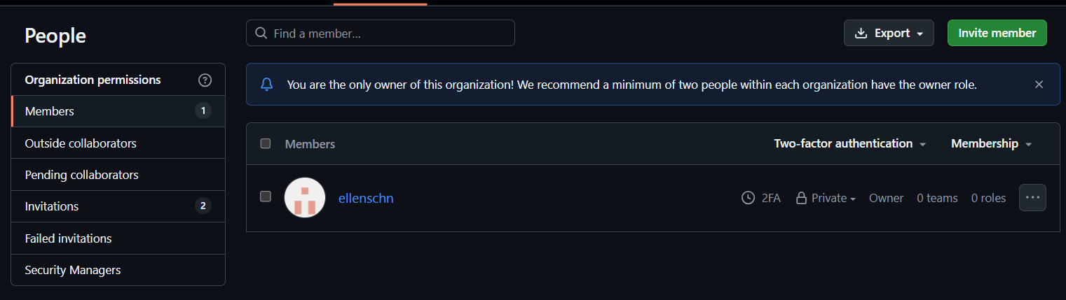

Simply type in their email address and invite!
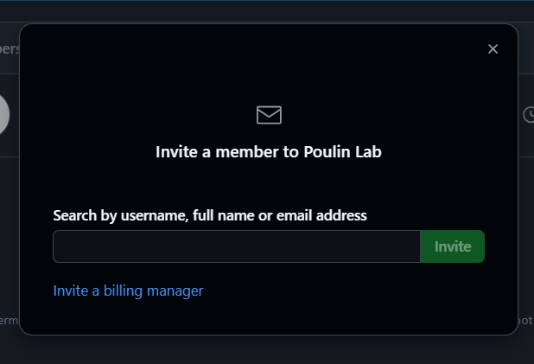
Note that it will ask you to give the person Member or Admin benefits. The lab organization is configured so that Members can add code, create and delete repos but cannot invite other collaborators. An administrator on the other hand, has full access to everything. You can additionally give “admin access” to a person for a particular repository.

Storing & Sharing Code
All code created and shared should be stored under the lab organization for ease of access and trackability.

Creating Repositories
A repository (or repo) can be thought of like a folder. It will contain related items to a particular experiment or project. Each repository should have a README file to detail information about that particular experiment.
To create a repository, navigate to the “+” button on the right hand side of the screen. 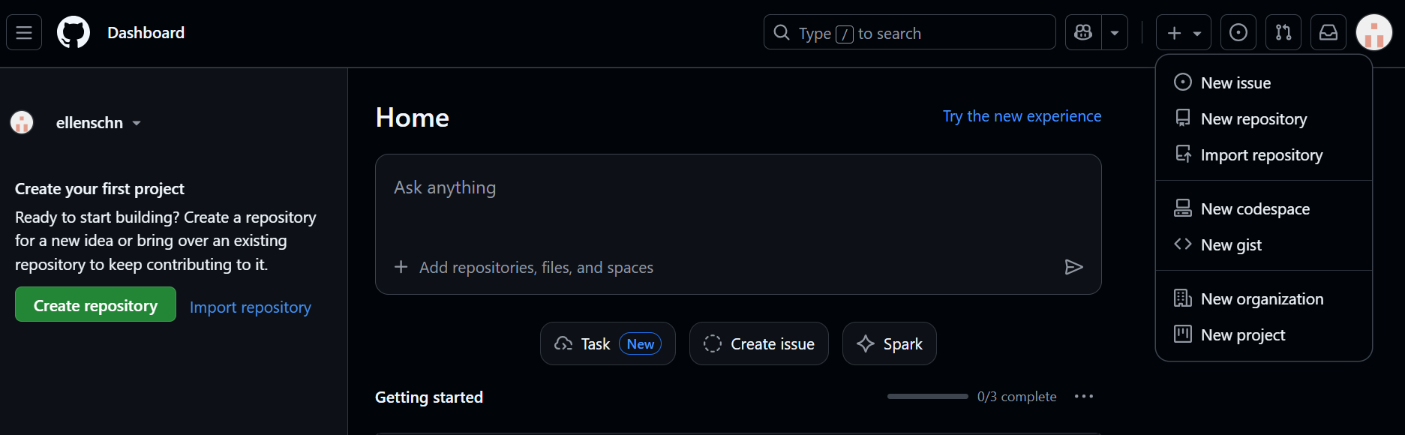
1
2
Name the repository accordingly. Ensure that the owner falls under “Poulin-Lab” and not your account so that everyone has access to the repository. Add a description if you like. Visibility should ideally be public, and README should be checked.
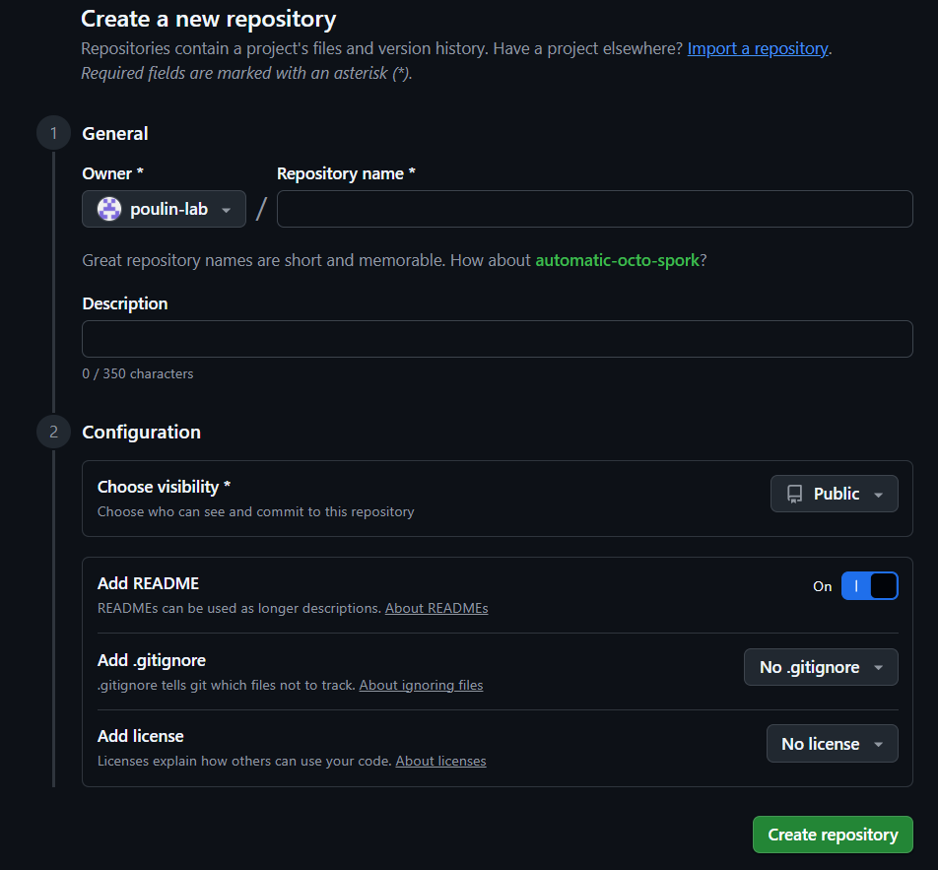
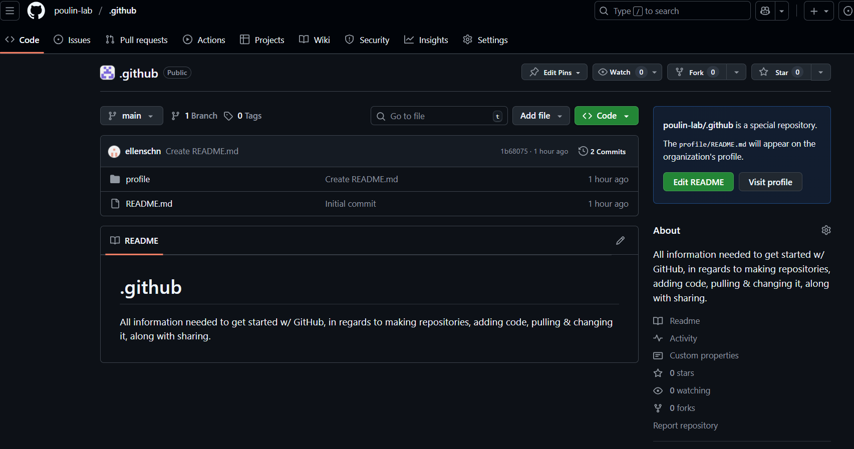

Adding Code
You can add code to any branch in a repository. For most cases in this lab, we’ll keep the final or official version in the main branch.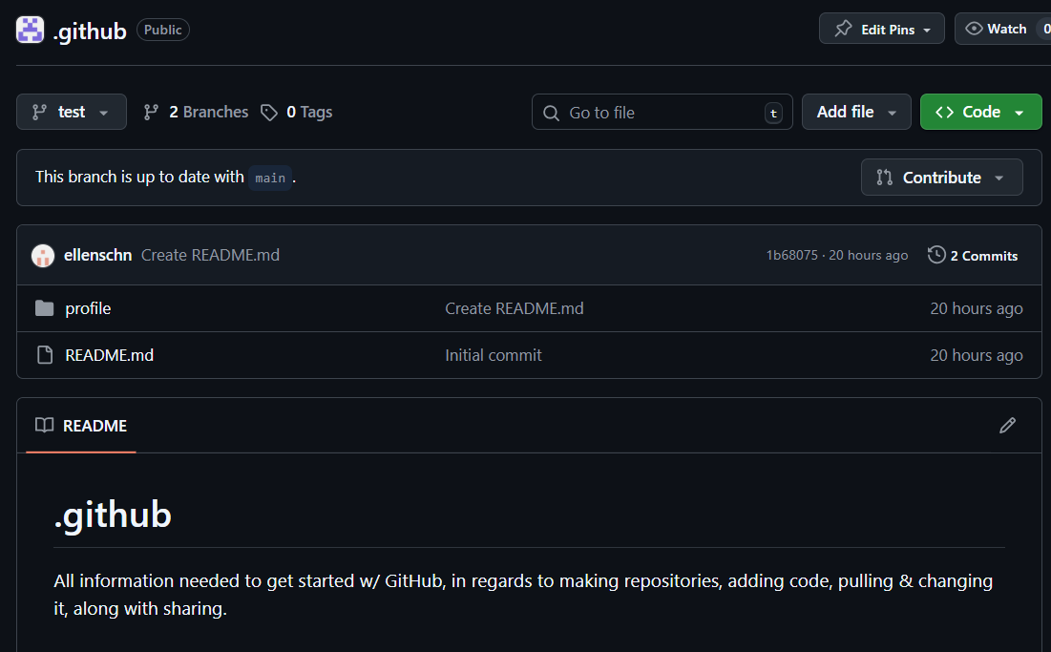 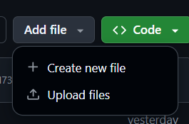 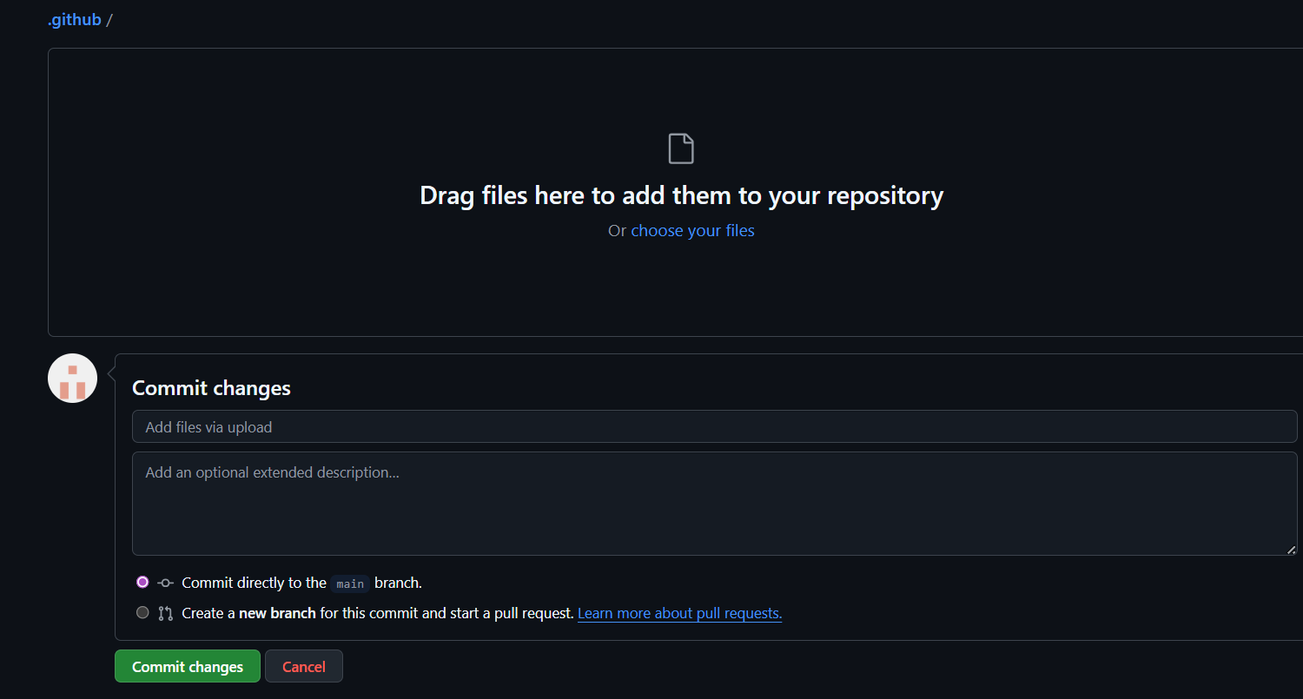

Name what you’re doing (ex. uploading file.py)

Note: you can upload just about anything (doesn’t have to be code)!

Sharing Code with Members Outside the Lab
Note: this is sharing for a particular repository, if you want someone to have full access to the organization, an administrator should invite them as a member of the lab.
Sharing code can be done to someone’s GitHub account or to an email address. To share a repository directly to a person, go to the repository’s Settings → Manage Access → Invite collaborators.
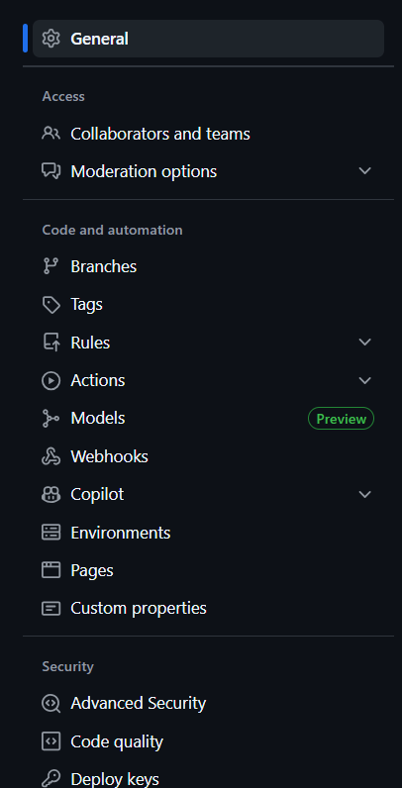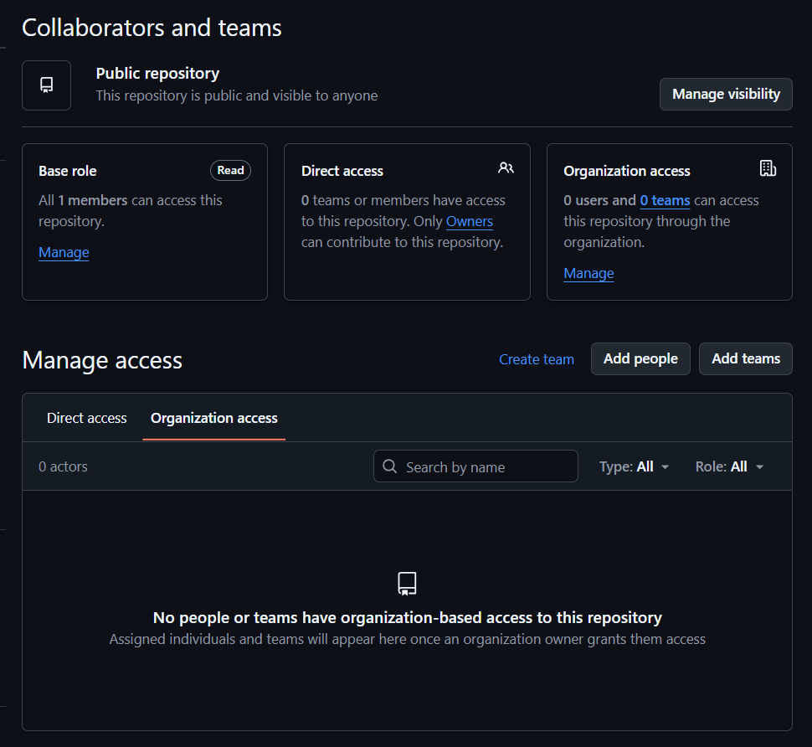

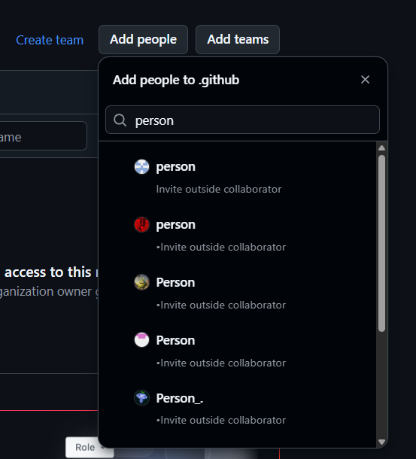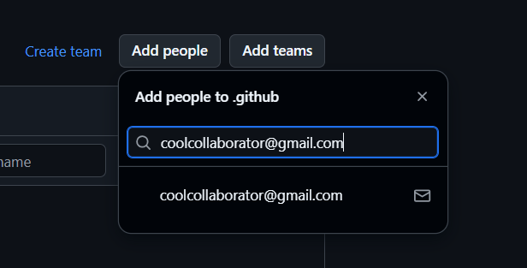
You can search to find people who already have a GitHub account or invite people directly through email. You can additionally modify someone’s access under the “Manage Access” box.
If the repository is public, an alternative is through a URL link. Note that this only allows others to see the code, they can not modify or add anything.

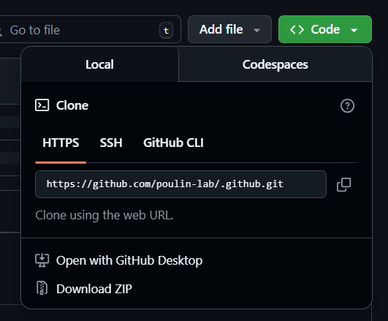
Simply copy the URL and anyone will be able to view the repository!

Modifying Code and Development
Code uploaded to GitHub can be modified and changed as needed. The best way to approach this is by creating branches off of main repositories, committing new changes, and sending pull requests to other lab members.

Creating Branches Within Repositories
A branch is a separate version of the code within a repository. It acts like a workspace where a user can make changes without affecting the main version. Each branch can have its own commits and updates, letting you experiment safely.
By default, all repositories have a main branch where the source code should be stored. There is no limit on how many branches a repository can have.
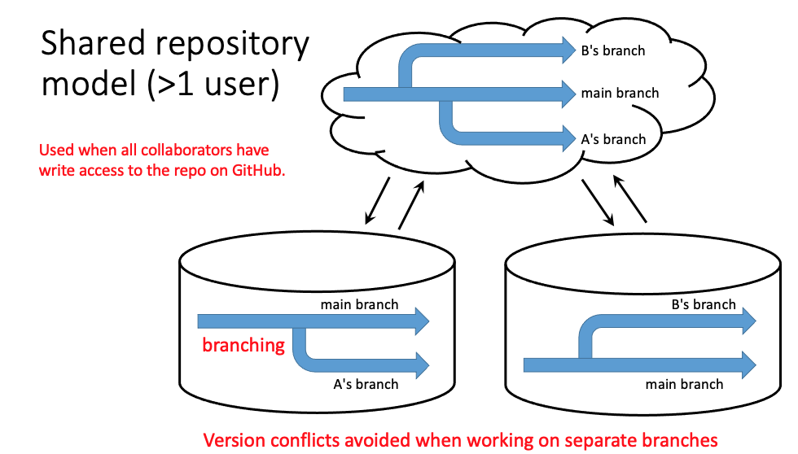
To create a new branch, go to the dropdown menu that says main. Create a name for your branch and click create.
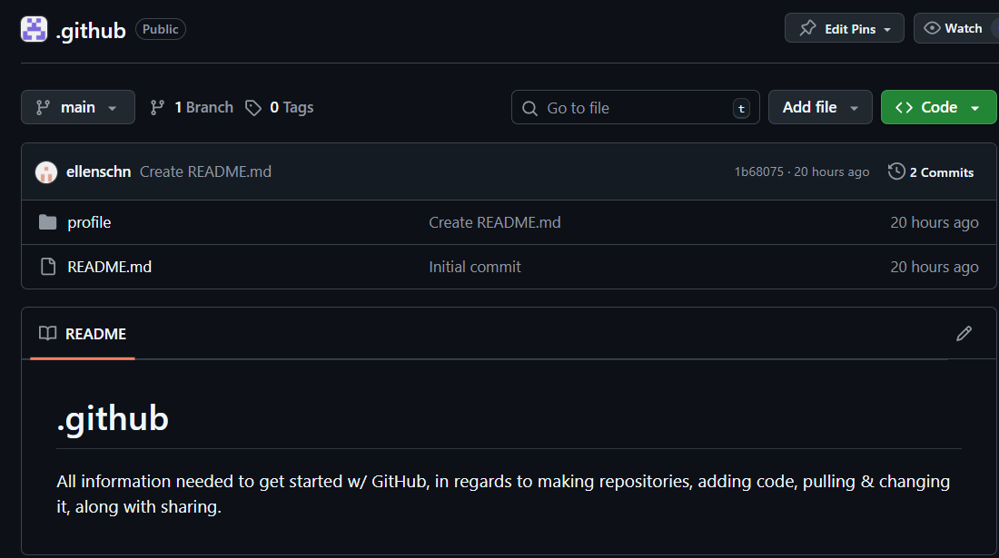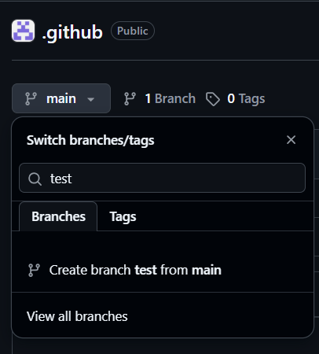
Name it as you’d like

Says test instead of mainin
A new branch starts as an exact copy of the main branch, but any changes you make in the new branch won’t affect the main branch. If the main branch gets updated after your branch is created, you can pull those updates into your branch as needed. If you want your branch’s changes to become part of the main branch, you’ll need to merge the branches.
To read more about branches: https://heardlibrary.github.io/digital-scholarship/manage/control/github/branch/

Committing Changes
In GitHub, saving any changes is called “committing”. Each commit has a title and an optional description (which is what you likely did just now by uploading code!) This allows for everyone to be aware of what changes are happening in the organization.
To modify any file, simply click on it and change it as you’d like. Once you’re done, you must click on “commit changes” and write a commit message that describes what you have done.
Click on whatever document you want to modify
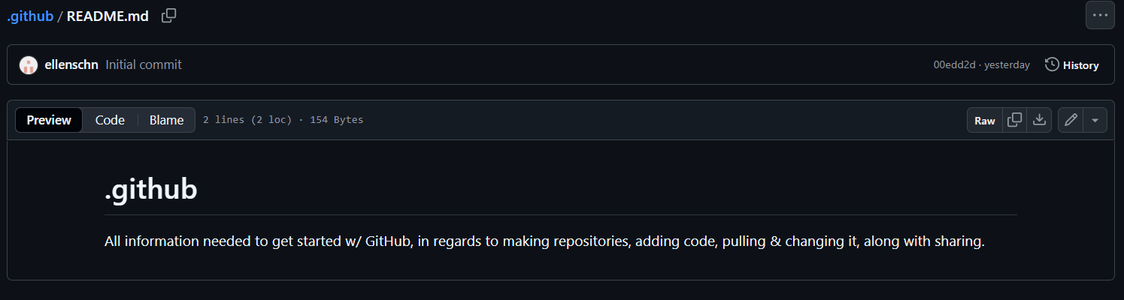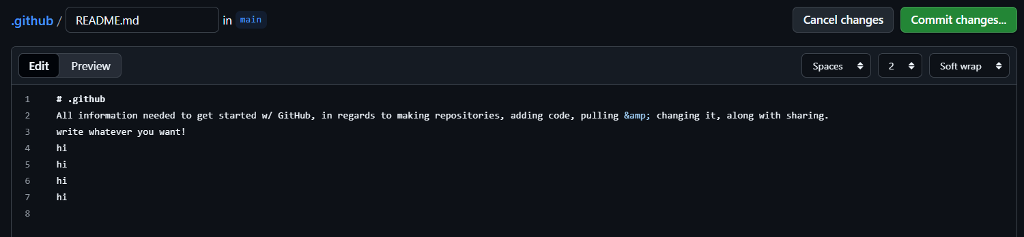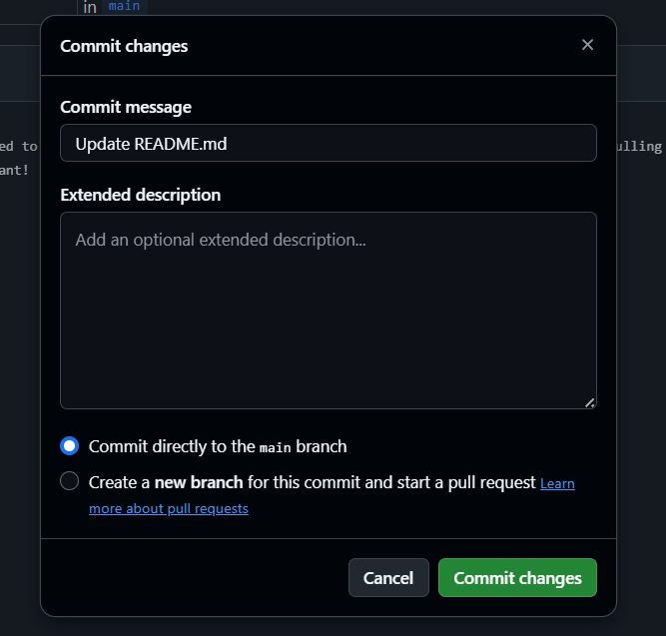

Name your change
Modify as needed

All recent commits are listed at the top of all files. Click on the number of commits to see a full list of changes.
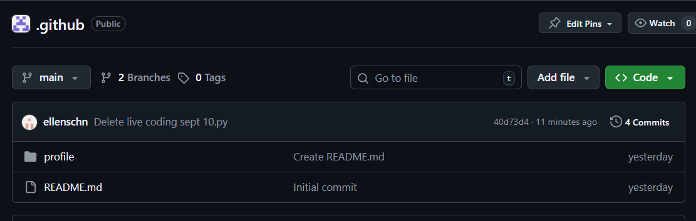

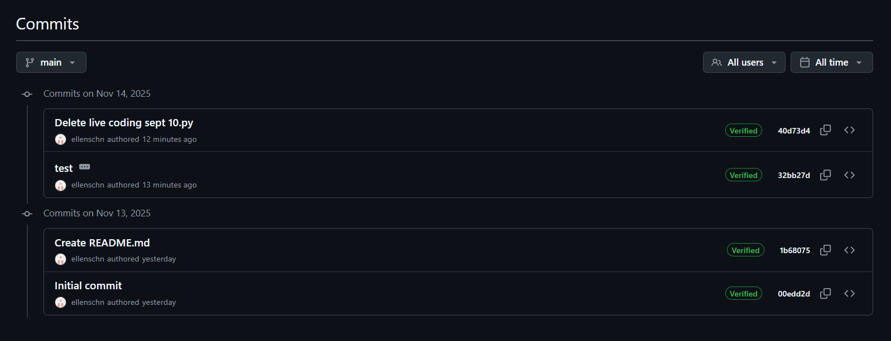

Pull Requests & Merging Branches
Pull requests are for when you want to merge your branch with the main branch. Creating a pull request will signal to other collaborators for their input and display all the commits you are proposing. To create a pull request, first go into the branch that you want to “pull” into the main branch. There should be a button at the top saying “Compare & pull request”.
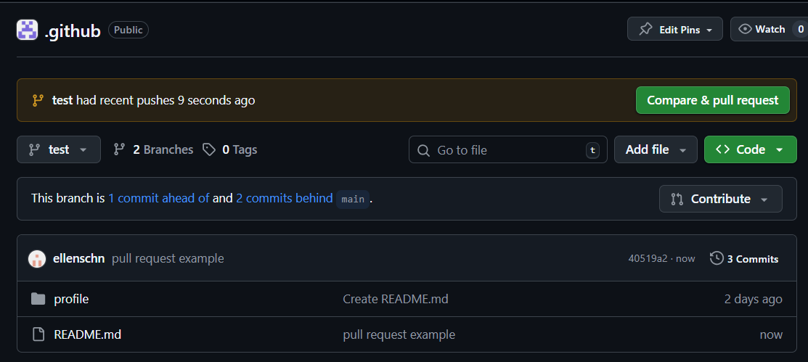

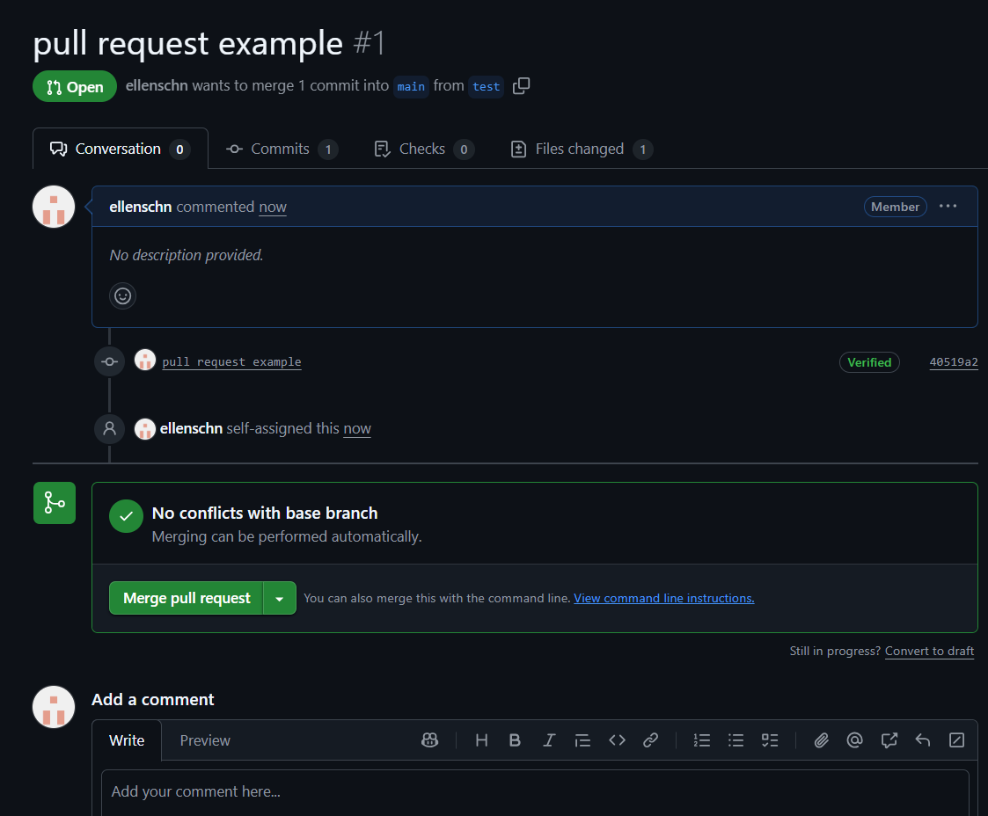
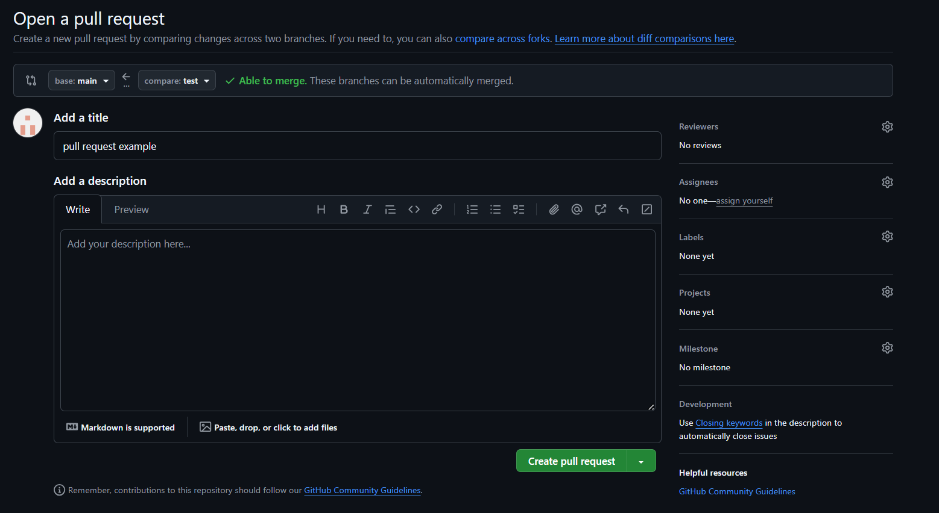
See exactly what gets added
Look at the commits proposed
Add to the conversation about the code

Description as needed
Can request reviewers (will be notified to look at the code)
Assignees are those who worked on the code
Title it as you’d like
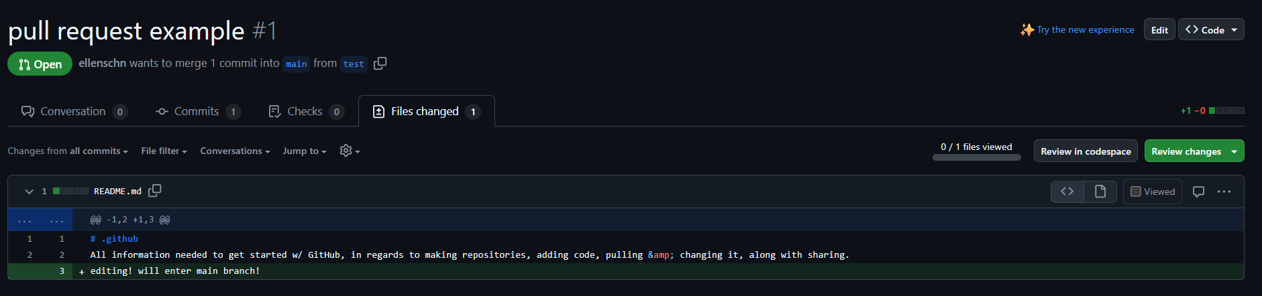
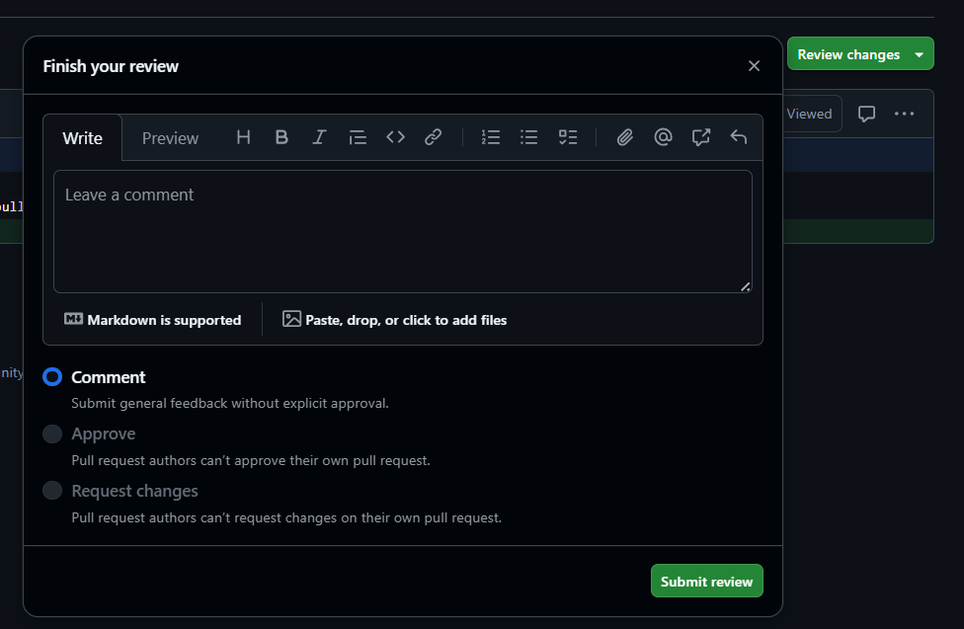
Say anything you want about the changes
If everything looks good, return to the conversation tab and click on “Merge pull request”.
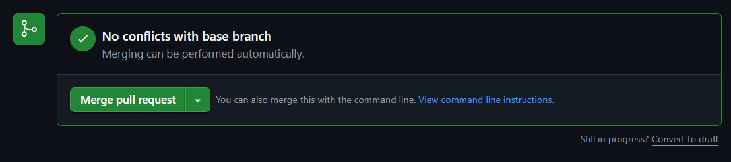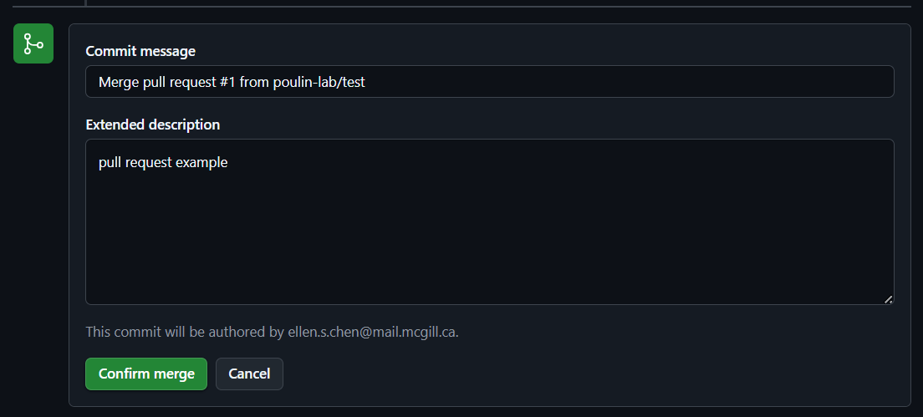

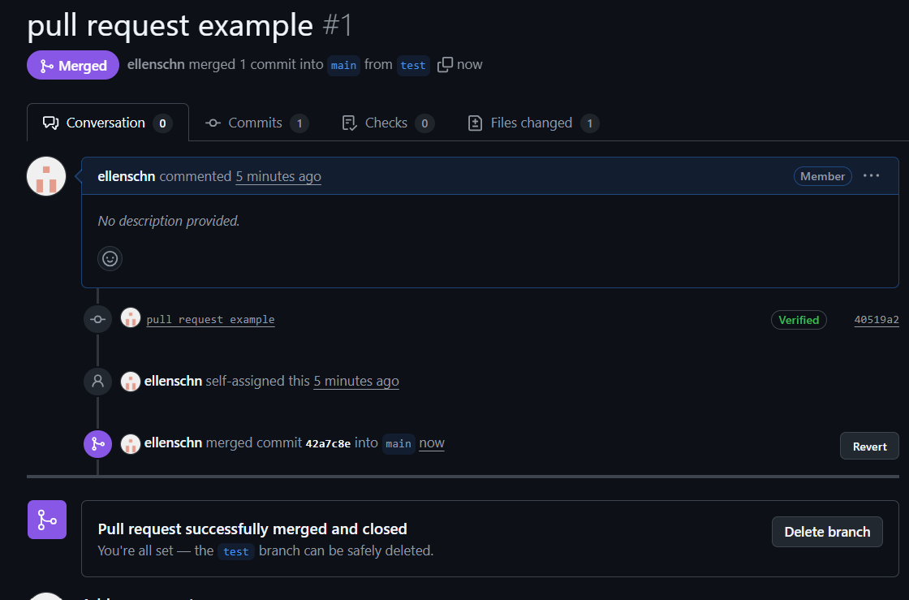
Now the two branches have successfully merged! Note that the “pulled” branch doesn’t get deleted. If you no longer have use for the branch, you will have to manually delete it.
Forking is another way to contribute to workflows. This is a more advanced technique, feel free to read about it here: https://docs.github.com/en/pull-requests/collaborating-with-pull-requests/working-with-forks/fork-a-repo

